First Baptist Church
After School Program
Policies and Procedures
Parent Handbook

95 W. Morse Street
Forsyth, Ga. 31029
(478) 994-5240

Revised February 2026

FIRST BAPTIST CHURCH
AFTER SCHOOL PROGAM
POLICIES AND PROCEDURES

The First Baptist Church, as a ministry to its members and the community, has established an After School childcare program to provide a safe and nurturing environment in a Christian atmosphere for school age children.

Enrollment is for children PreK thru 5th grade. Selective 6th – 9th graders

The program will run during the Monroe County school calendar year (August through May). The program will be closed during the following school holidays: Labor Day, Fall, Thanksgiving, Christmas, MLK, Winter, Spring, Memorial Day and teacher work days.

The days of operation will be Monday through Friday.

The hours of operation will be from 3:15 p.m. until 6:00 p.m., Monday, Tuesday, Thursday and Friday. On Wednesdays, pick up is at 5:30PM, your child must be picked up by 5:30.

Admission requirements include submitting a completed enrollment form and a non refundable registration fee.

Tuition is due each month the child is enrolled in the program whether present or absent.
Tuition is due in advance on the first day of each month. An additional charge will be required for monthly fees paid after the tenth day of each month. Late pick-ups will be charged $1.00 per minute after closing time. A fee will be charged on all return checks.
The parent or guardian who signs the parental agreement form is responsible for the timely payment of all fees. If the parent or guardian sees that the fees cannot be paid on time he/she has the responsibility to make acceptable arrangements with the director before the payment is due. If an acceptable agreement cannot be reached between the two parties, the contract for services for the child will be terminated.

(Revised February 2026)

The Monroe County School bus system will provide transportation to the church from Hubbard Elementary School. The church van will provide transportation from T.G. Scott and K.B. Sutton Elementary Schools. Pick-up from any other school is the parent’s responsibility.
Children who arrive by the Monroe County school bus will be escorted into the facility by a teacher or authorized person. Children arriving to the center by car must be escorted into the building and signed in.
A child shall not be accepted nor allowed to remain at the center if the child has the equivalent of a 100.4 degrees Fahrenheit fever and another contagious symptom such as a rash, diarrhea or a sore throat. When a child shows symptoms of illness during his/her stay, the child shall be moved to a quiet area away from other children. A parent will be notified to pick up the child.
The program will exercise reasonable care and judgement in all matters related to the welfare and safety of the child. In case of an accident or illness to the child, the teacher or director will promptly take such reasonable measures as are, in her/his judgement, in the best interest of the child and will notify the parents as soon as possible. This may include removing the child from the classroom under the supervision of a teacher or director.
In case of illness or accident when a parent cannot be contacted by the center and if, in the judgement of the teacher or director, the illness or accident requires a physician, the doctor in the child’s file may be called at the expense of the parent. In all emergencies, the program has permission to take such reasonable measures as are, in the judgement of the teacher or director, necessary for the welfare and safety of the child. If emergency medical attention is required, and the parent or guardian cannot be contacted, the child will be taken to the Monroe County Hospital emergency room.
FBC After School staff have been trained to prevent shaken baby/child syndrome and recognize abusive head trauma. In their training they are trained to recognize, response to and report any suspicion of shaken baby/child syndrome and abusive head trauma.
Emergency plans have been developed and are posted in our center for parents to view. In the event of an emergency such as a fire, we will move the children to the large playground across the one-way street adjacent to the church. In case of severe weather, we will move to the basement hall of the building. A diagram is enclosed.

(Revised February 2026)
The program is not liable for accidents or illnesses occurring to the child while he/she is in the program’s care unless proof is presented that the accident or illness was the direct result of the worker’s negligence.
The After School program will provide a daily nutritional snack while following the USDA guidelines. A monthly menu is posted. Special dietary needs, if submitted in writing, will be considered when preparing the menu.
In addition to physical care, the program will provide emotional, social, mental, and spiritual/moral development opportunities in a group situation. The program will provide resources to allow for a variety of appropriate activities during the day.
Children must adhere to the rules and be cooperative and respectful of the staff and other children. Discipline measures will be handled by using the time-out method. Parents will be notified of behavior problems. The director may request special conferences if problems persist without resolution. Liability for a child’s action under the care of the program is the parent’s responsibility. The weekday program reserves the privilege of dismissing any child if he/she seems unable to participate in group activities. You will also find a detailed discipline policy on the last few pages of this handbook.
Children will not be allowed to leave the facility without being signed out and escorted by the parent or guardian, or authorized person. The program will not release the child to anyone other than the parent or guardian unless permission is received from the parent or guardian. Anyone picking up a child other than the parent or guardian will be asked to show ID. Parents must notify the center in writing or by phone if the child is to be picked up by someone other than the authorized persons listed on the registration form. A picture ID is required.
It is the parent’s responsibility to keep the child’s record current to reflect any significant changes as they occur such as telephone numbers, work location, emergency contacts, child’s physician, child’s health status etc.
The First Baptist Church After School Program must obtain written authorization before any child participates in routine transportation, field trips, special activities away from the center, or water related activities occurring in water that is more than two feet deep.

(Revised February 2026)

FBC After School Tuition Schedule for 2026-2027

Registration Fee ( Non refundable)

$50.00/Child

Tuition

$165.00 / month per child

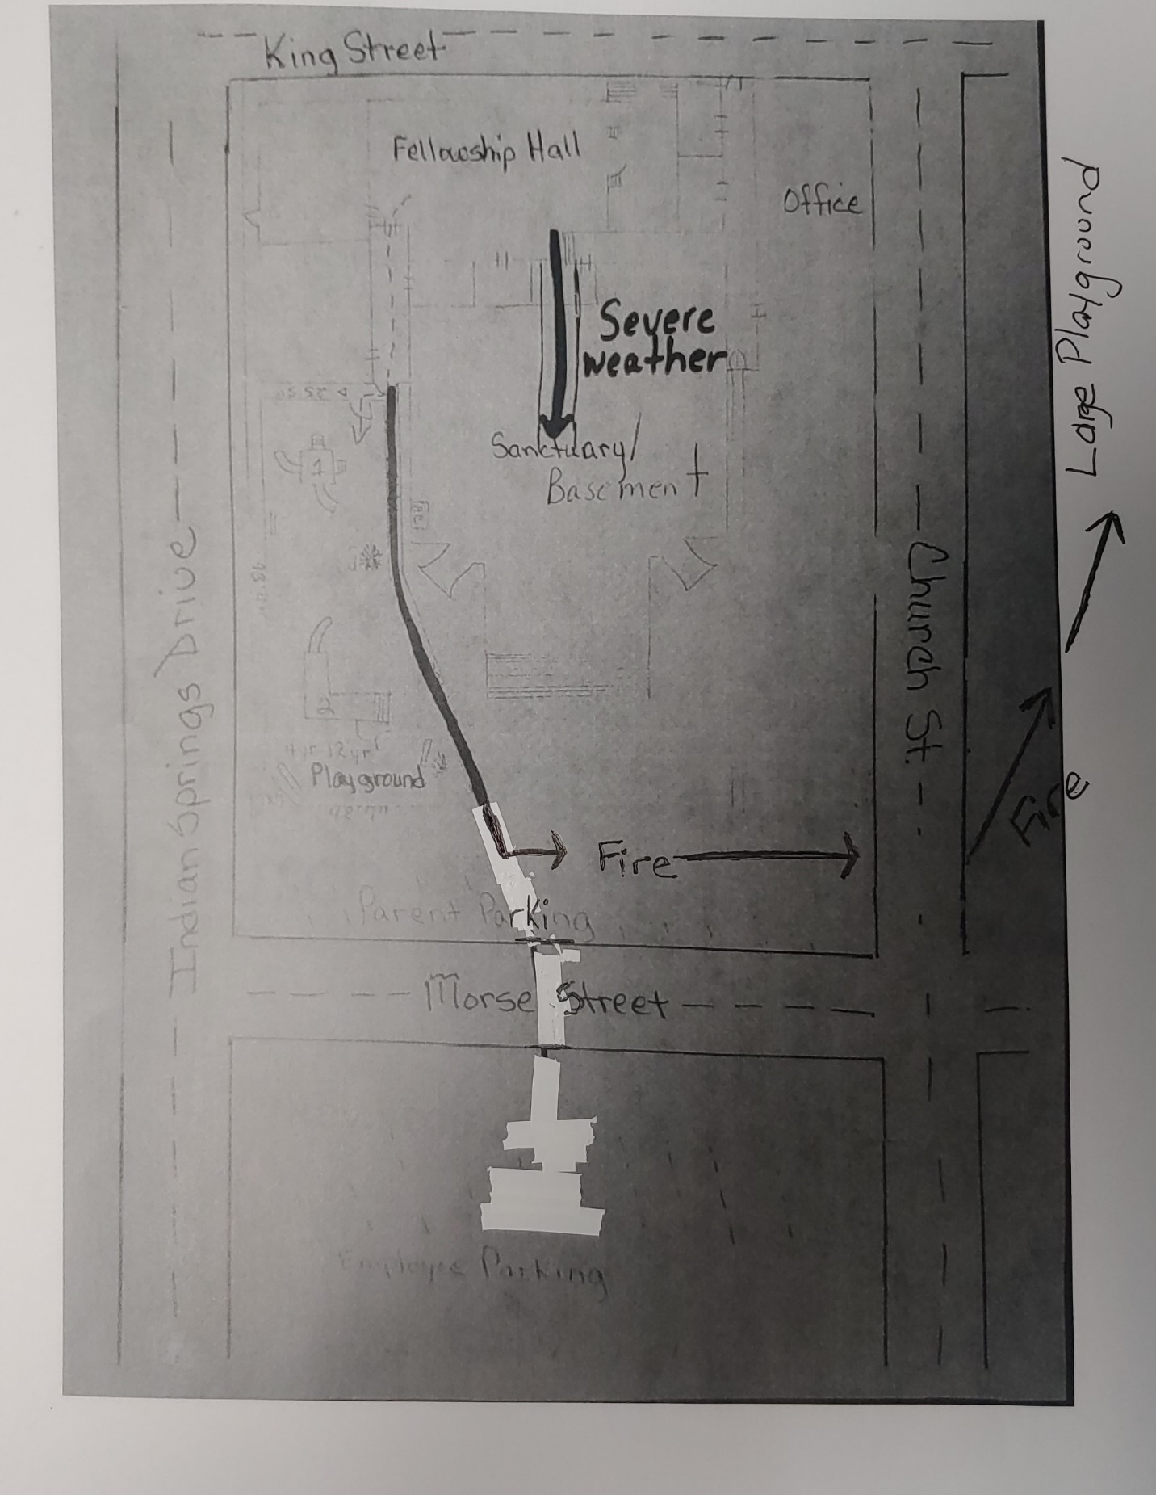

First Baptist Church of Forsyth – After School Discipline Policy

Praise and positive reinforcement are effective methods of behavior management of children. When children receive positive, nonviolent, and understanding interactions from adults and others, they develop good self-concepts, problem solving abilities, and self-discipline. Based on this belief, First Baptist Church of Forsyth Preschool Program uses a positive approach to discipline and practices the following discipline and behavior management techniques.

WE DO ♦ Communicate to children using positive statements. ♦ Communicate with children on their level. ♦ Talk with children in a calm quiet manner. ♦ Explain unacceptable behavior to children. ♦ Give attention to children for positive behavior. ♦ Praise and encourage the children. ♦ Reason with and set limits for the children. ♦ Apply rules consistently. ♦ Model appropriate behavior. ♦ Set up the classroom environment to prevent problems. ♦ Provide alternatives and redirect children to acceptable activity. ♦ Give children opportunities to make choices and solve problems. ♦ Help children talk out problems and think of solutions. ♦ Listen to children and respect the children’s needs, desires and feelings. ♦ Provide appropriate words to help solve conflicts. ♦ Use storybooks and discussion to work through common conflicts.

WE DO NOT ♦ Inflict corporal punishment in any manner upon a child. (Corporal punishment is defined as the use of physical force to the body as a discipline measure. Physical force to the body includes, but is not limited to, spanking, hitting, shaking, biting, pinching, pushing, pulling, or slapping.) ♦ Use any strategy that hurts, shames, or belittles a child. ♦ Use any strategy that threatens, intimidates, or forces a child. ♦ Use food as a form of reward or punishment. ♦ Use or withhold physical activity as a punishment. ♦ Shame or punish a child if a bathroom accident occurs. ♦ Embarrass any child in front of others. ♦ Compare children. ♦ Place children in a locked and/or dark room. ♦ Leave any child alone, unattended or without supervision. ♦ Allow discipline of a child by other children. ♦ Criticize, make fun of, or otherwise belittle a child’s parents, families, or ethnic groups.

Conferences will be scheduled with parents if particular disciplinary problems occur. If a child’s behavior consistently endangers the safety of the children around him/her, then the Director has the right, after meeting with the parents and documenting behavior problems and interventions, to terminate child care services for that particular child.

